Name: Reg No.:
Section:F1 Marks:10

Graded Lab 04

Name: ABBBBU BKKKKRRRRRRRR

Open Wireshark, select interface from list of interfaces (Ethernet in your case). Change your Interface to the appropriate one from the list provided. Then Press the capture Start button to start capturing the packets at run time.
- While Wireshark is running, enter the URL:
http://gaia.cs.umass.edu/wireshark-labs/INTRO-wireshark-file1.html and have that page displayed in your browser.
- Now enter another URL http://gaia.cs.umass.edu/favicon.ico and you will see that this page is not found on the server.
- In order to display both the pages, your browser will contact the HTTP server at gaia.cs.umass.edu and exchange HTTP messages with the server in order to download this page. The Ethernet frames containing these HTTP messages will be captured by Wireshark.
- After your browser has displayed both the web pages, stop Wireshark packet capture by selecting stop in the Wireshark capture window. You now have live packet data that contains all protocol messages exchanged between your computer and other network entities! The HTTP message exchanges with the gaia.cs.umass.edu web server should appear somewhere in the listing of packets captured. But there will be many other types of packets displayed as well.
- Type in “http” (without the quotes, and in lower case – all protocol names are in lower case in Wireshark) into the display filter specification window at the top of the main Wireshark window. Then select Apply (to the right of where you entered “http”). This will cause only HTTP message to be displayed in the packet-listing window.

Questions:

1.Is your browser running HTTP version 1.0 or 1.1? What version of HTTP is the server running?
http version:
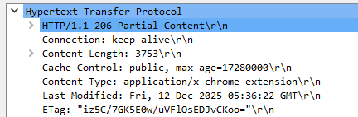

Server version
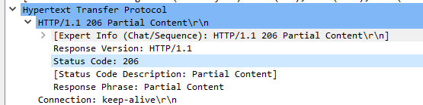

2.What languages (if any) does your browser indicate that it can accept to the server?

Ans:

The browser does not indicate any accepted language, as the Accept-Language header is absent.

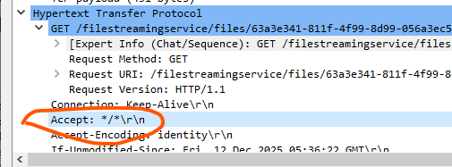

3.Identify and list the source and destination IP addresses from the packet headers.

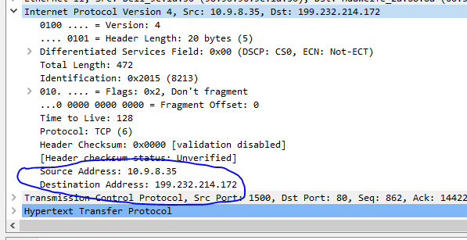

4.From the Hex dump, what is the value of the "Protocol" field in the IP header? What protocol does this value represent?
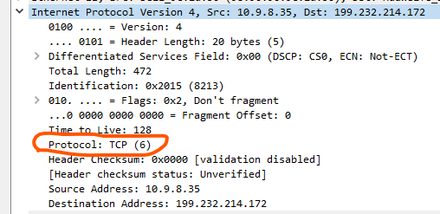

5.How many bytes of total packet content are being returned to your browser?

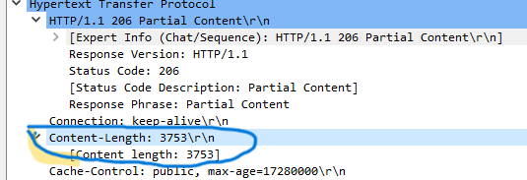

Attach the screenshots of all answers. Otherwise it would be marked zero.

